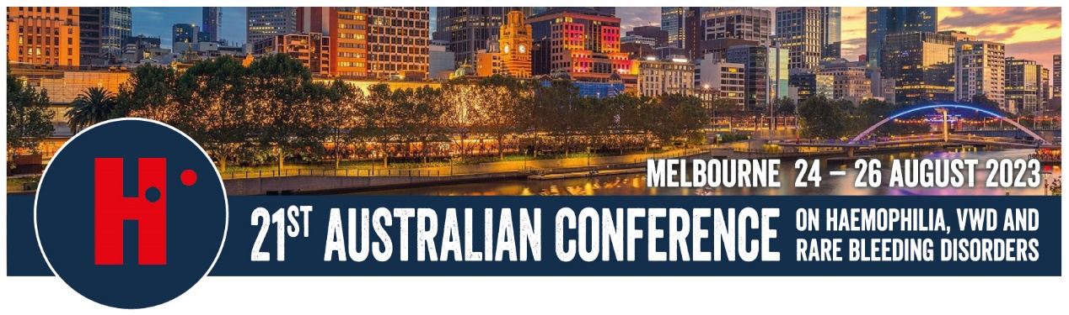

COMMUNITY FUNDING AVAILABLE FOR NATIONAL CONFERENCE 2023

The 21st Australian Conference on haemophilia, VWD & rare bleeding disorders will be held in Melbourne from 24-26 August 2023.

For information about the conference, registration and accommodation costs visit http://www.haemophilia.org.au/conferences.

- HFQ has allocated funding to assist people living with a bleeding disorder, relatives/partners or carers to attend the Conference
- You will generally be expected to contribute towards your costs
- Part funding applications are encouraged so we increase access
- Please advise if you will be requesting or have received funding offers from other sources
- Applications will be assessed on their merit – it is in your interests to provide full responses to the questions on the application form
- Applications only open to Australian residents

General Costs (for more details visit our website)
Accommodation - $260 per night inc bed and breakfast
Person with a Bleeding Disorder Conference Registration $250
Other Events:
Conference Dinner $70
Men’s/Women’s Breakfast $30

Application Form
Send your application as soon as possible so your application for funding can be considered.

For further information
Lauren Green
E: info@hfq.org.au
P: 0419 706 056

APPLICATION FORM 2023

Name:
Address:
Phone:
Email:

ELIGIBILITY: We do not require personal health information, however we need to be sure you are a person with a bleeding disorder, a relative or a carer, and therefore eligible to receive HFA funding – please tick relevant box and list a contact person at your Haemophilia Centre or local foundation for confirmation.

I have a bleeding disorder
I am a relative, carer/partner of a person with a bleeding disorder

Name and contact details of someone at your Haemophilia Centre or your local Haemophilia Foundation for confirmation

EXPECTED COSTS
(see registration form for full costs https://tinyurl.com/bdeneecm)
Item | $
Conference Registration
Accommodation
Flight/Transport Costs
Other Expenses - specify
TOTAL EXPECTED COSTS
PERSONAL CONTRIBUTION
(What can you contribute towards the costs)
CONTRIBUTION FROM OTHER SOURCES
(State/territory haemophilia foundation funding, other sources)
TOTAL FUNDING REQUESTED

Have you attended a national haemophilia conference or international congress before? YES NO
If so, please specify
Have you received HFA or local Foundation funding for a conference or congress before? YES NO
If so, please specify
Please describe how you will benefit from attending the Conference and why you want to attend

How will others benefit from your attendance? Who will benefit?

Will you be attending the Conference with anyone else/will you be sharing costs?
If so, please explain further

Are you a current financial member of HFQ?

Any other comments or supporting information you would like to share (add another page if required)

Signed: Date:

